# CORRELATION AND REGRESSION

## PRBOLEM STATEMENT

Students are asked to visit in the different departmental store to collect the information about the demand of the electric items and their respective price.

Prepare a note on a correlation between the demand of electric items and the price. Present the report with conclusion on the class.

## INTRODUCTION

Correlation is a statistical measure that express the extent to which two variables are linearly related. It’s a common tool for describing simple relationship without making a statement about cause and effect.

There are three basic types of correlation:

* Positive Correlation

It is a relationship between two variables in which the both variables are directly proportional to each other. The value of coefficient of correlation is always greater than one for Positive Correlation.

* Negative Correlation

It is a relationship between two variables in which the two variables are inversely proportional to each other. The value of coefficient of correlation is always less than one for Negative correlation.

* Zero Correlation

It is the correlation which exists when there is no relationship between two variables.

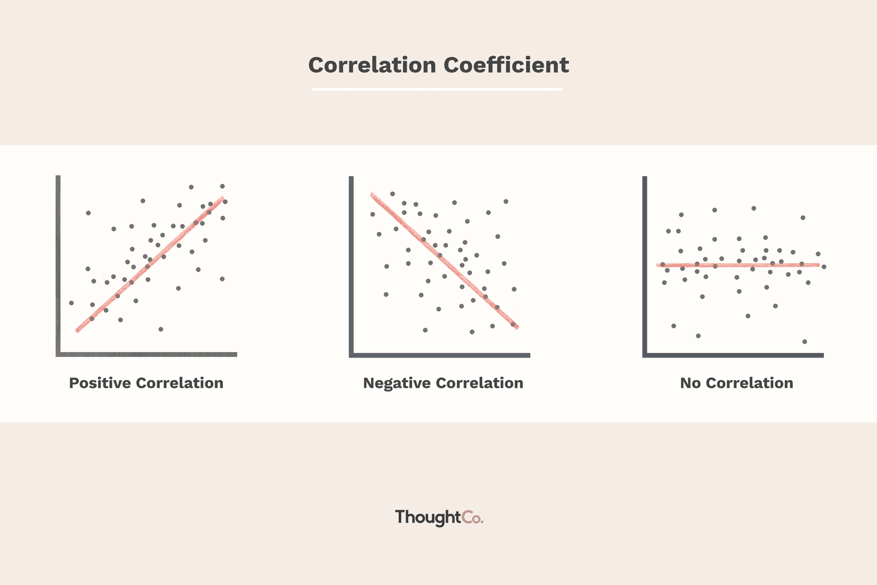

## HISTORICAL BACKGROUDs

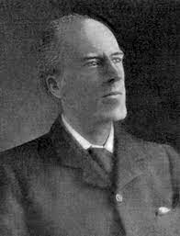The concept of correlation was introduced by Francis Galton’s in 1888 A.D. He also created the statistical concept of correlation and widely promoted regression toward the mean. Sir Francis Galton pioneered correlation Galton, a cousin of Charles Darwin, did a lot: he studied medicine, he explored Africa, he published in psychology and anthropology, he developed graphic techniques to map the weather And, like others of his era, Galton strove to understand heredity

Karl Pearson, Galton’s colleague and friend and father of Egon Pearson, pursued the refinement of correlation with such vigor that the statistic *r*, a statistic Galton called the index of co-relation and Pearson called the Galton coefficient of reversion, is known today as Pearson’s *r.*

## OBJECTIVE

* Collecting the information about the demand of the electric items and their respective price.
* Represent the collected information in a Graph.
* Finding the coefficient of correlation between the demand of electric items and their respective price.
* Concluding the relation between the demand of electric items and their respective price.

## KEY FEATURES

* The value of coefficient of correlation varies between -1 to +1.
* The formula to calculate Karl Pearson’s correlation coefficient is $r=\frac{cov\left(x,y\right)}{σx. σy}=\frac{N.\sum{X.Y}-\sum{X}.\sum{Y}}{\sqrt{N.\sum{X^{2}-{\left(\sum{X}\right)}^{2}}}.\sqrt{N.\sum{Y^{2}}-{\left(\sum{Y}\right)}^{2}}}$
* Correlation coefficient is a pure number. It has no unit.
* The correlation coefficient is independent of change of origin and unit of measurement $i.e. r_{xy}=r_{uv}.$
* The correlation coefficient is symmetrical with respect to X and Y $i.e.. r_{xy}=r_{yx}.$
* The value of coefficient of Alienation $\left(k\right)=\sqrt{1-r^{2}}$.
* The formula to find Spearman’s rank correlation coefficient, usually denoted by (Rho) or R is $R=1-\frac{6\sum{d^{2}}}{N\left(N^{2}-1\right)}$ where, d is difference between the rank of two items, N is the number of pairs of observation.
* Correlation is confined only in linear relationship with the variables.
* It measures the direction and degree of liner relationship between two variables.
* If the correlation coefficient between two variables is 1, then the two least square lines of regression are coincident.
* In scatter diagram, if the slope of line is negative then the correlation coefficient is negative and if the slope of line is positive then the correlation coefficient is positive. And if the slope of line is zero then the correlation coefficient is zero.

## COLLECTION OF INFORMATION

Electrical appliances like computer, hard disk, electrical fans, bulb etc. So, for the convenience low price electrical item is taken like battery, bulb etc. are taken for this project. Among them, bulb is taken as the main items for the calculation of correlation coefficient.

Firstly, the information about the bulb price per piece and their respective price per piece with increase in demand is noted down. According to the head of departmental store, certain discount is given with respect to increase in no of bulb.

As per the information given by the departmental store, the price per piece with respective demand of bulb is given in following table:

|  |  |  |  |  |  |  |  |  |  |  |
| --- | --- | --- | --- | --- | --- | --- | --- | --- | --- | --- |
| X | 1 | 5 | 10 | 15 | 20 | 25 | 30 | 35 | 40 | 45 |
| Y | 100 | 98 | 95 | 92 | 90 | 85 | 80 | 79 | 77 | 75 |

In the given table, X represent the demand of bulb and Y represent the price of bulb per piece.

## NUMERICAL COMPUTATION

Collected information about the demand of bulb and their corresponding price per piece is further proceed for the numerical calculation to find the exact value of correlation coefficient. The method for finding the value of correlation coefficient is known as Karl Pearson’s correlation method. By using this method the value of correlation coefficient is calculated as like below table.

|  |  |  |  |  |
| --- | --- | --- | --- | --- |
| X | Y | $$X^{2}$$ | $$Y^{2}$$ | $$X.Y$$ |
| 1 | 100 | 1 | 10000 | 100 |
| 5 | 98 | 25 | 9604 | 490 |
| 10 | 95 | 100 | 9025 | 950 |
| 15 | 92 | 225 | 8464 | 1380 |
| 20 | 90 | 400 | 8100 | 1800 |
| 25 | 85 | 625 | 7225 | 2125 |
| 30 | 80 | 900 | 6400 | 2400 |
| 35 | 79 | 1225 | 6241 | 2765 |
| 40 | 77 | 1600 | 5929 | 3080 |
| 45 | 75 | 2025 | 5625 | 3375 |
| $\sum{X=}$ 226 | $\sum{Y}=$ 871 | $\sum{X^{2}}=$ 7126 | $\sum{Y^{2}}=$ 76613 | $\sum{X.Y}=$ 18465 |

N=10,

Here,

The formula to find the coefficient of correlation is given by:

∴ $r=\frac{N.\sum{X.Y}-\sum{X}.\sum{Y}}{\sqrt{N.\sum{X^{2}-{\left(\sum{X}\right)}^{2}}}.\sqrt{N.\sum{Y^{2}}-{\left(\sum{Y}\right)}^{2}}}$

Or, r= $\frac{10×18465-226×871}{\sqrt{10×7126-{226}^{2}}\sqrt{10×76613-{871}^{2}}}$

Or, r= $\frac{-12196}{142.07×86.539}$

Or, r= $-0.99198$

Hence, the value of correlation coefficient is negative 0.99198.. which is nearly perfect negative correlation.

## GRAPHICAL REPRESENTATION

The relation between the demand of electrical appliance and their corresponding price is plotted in a graph which is known as scatter diagram. The scatter diagram is given as:

In the above graph, the independent variable (i.e. demand of electrical bulb) is plotted in X-axis direction and the dependent variable (i.e. price of electrical bulb per piece) is plotted in Y-axis direction.

## CONCLUSION

The value of Karl Pearson’s correlation coefficient between the demand of bulb and their respective price per piece is nearly equal to perfect negative correlation $r≈-1$. Hence, we can conclude that the relation between the demand of bulb and their corresponding price per piece is inverse i.e. if we bulb one piece bulb then it will be expensive with compare to buy two bulb or more bulb as per the discount given by the seller.

## APPLICATION

* It is used for finding the relation between any two or more physical quantity whether the quantity are inversely or directly proportional to each other. Such as the relationship between force applied on the body and mass of that body to accelerate is directly proportional to each other.
* It is used for economists to study the relationship between variables like price and quantity demanded. Also for the businessman, it help to estimate costs, sales, price and other related variables.
* The correlation coefficient is a relative measure and we can compare the relationship between variables which are expressed in different units.
* Sampling errors can be calculated.
* It is used in share marketing to find the relation between the share price and share demands in market.
* It is used for financial interpretation and help for making decision in a company.

## REFERENCES

1. Nabaraj Adhikari, Amba Datt Joshi, Nabaraj Bhandari, Raghu Bir Bhatta, Hari Prapanna Kandel, *Principle of mathematics,* Kriti Publication Pvt.Ltd., Putalishadak, Kathmandu
2. N. Adhikari, H.N. Nath and et.al. *Pioneer Mathematics Grade XI and XII,* Dreamland Publication Pvt.Ltd.2014, Kathmandu, Nepal.
3. P.M. Bajracharya and G. Basnet, *Fundamental of Mathematics,*  class XI and XII, Buddha Academic, 2008, Nepal.